Assignment -02

Task 01: Please conduct multiple Protein-Ligand Docking and provide the top 10 results in the following table.
 | Ligands | Binding  Affinity | Rmsd/ub | Rmsd/ib
01 | e4u9c_6436348_uff_E=402.80 | -6.2 | 0 | 0
02 | e4u9c_10104370_uff_E=146.78 | -5.5 | 0 | 0
03 | e4u9c_196216_uff_E=215.06 | -5.5 | 0 | 0
04 | e4u9c_14529_uff_E=139.23 | -5.5 | 0 | 0
05 | e4u9c_79035_uff_E=1568.10 | -5.4 | 0 | 0
06 | e4u9c_5315469_uff_E=160.58 | -5.3 | 0 | 0
07 | e4u9c_28930_uff_E=387.47 | -5.2 | 0 | 0
08 | e4u9c_7463_uff_E=91.91 | -5 | 0 | 0
09 | e4u9c_7461_uff_E=63.24 | -5 | 0 | 0
10 | e4u9c_31253_uff_E=90.99 | -4.5 | 0 | 0

Task 02: Please perform ADME analysis on the 10 compounds obtained from the Protein-Ligand Docking and provide the results in the table
below.
ADME Analysis |  |  |  |  |  |  |  | Pharmacokinetics |  | Drug likeness | Medicinal Chemistry
Name | CID ID | Canonical SMILES | Molecular weight | Num  . H-  bon d  acce ptor  s | Num. H-  bond donors | Lipophilicity (iLOGP) | Water Solubility (Log S (SILICOS- IT)) | GI absorption | BBB  permeant | Lipinski | PAINS
beta- Bisab olen  e |  | CC(=CCCC(=C)[C @H]1CCC(=CC1) C)C | 204.35 | 0 | 0 | 3.67 | -3.58 | Low | No | 1 | 0
2-(4-  Meth ylphe nyl)p ropa n-2-  ol |  | Cc1ccc(cc1)C(O)( C)C | 150.22 | 1 | 1 | 2.17 | -3.01 | High | Yes | 0 | 0
Myrc ene |  | C=CC(=C)CCC=C(  C)C | 136.23 | 0 | 0 | 2.89 | -2.42 | Low | Yes | 0 | 0
alpha  - |  | Cc1ccc(cc1)C(O)(  C)C | 150.22 | 1 | 1 | 2.17 | -3.01 | High | Yes | 0 | 0

Fenc
hene
gam ma- Terpi  nene |  | CC1=CCC(=CC1)C (C)C | 136.23 | 0 | 0 | 2.73 | -2.23 | Low | Yes | 0 | 0
Bisac umol |  | CC(=CC(CC(c1ccc(  cc1)C)C)O)C | 218.33 | 1 | 1 | 2.87 | -3.97 | High | Yes | 0 | 0
Curlo ne |  | CC(C1CCC(=C)C= C1)CC(=O)C=C(C)  C | 218.33 | 1 | 0 | 3.14 | -2.9 | High | Yes | 0 | 0
p-  Cym  ene |  | Cc1ccc(cc1)C(C)C | 134.22 | 0 | 0 | 2.51 | -3.57 | Low | Yes | 1 | 0
Ger macr  one |  | C/C/1=CCC(=C(C)  C)C(=O)C/C(=C/C C1)/C | 218.33 | 1 | 0 | 2.88 | -3.64 | High | Yes | 0 | 0
Tricy clene |  | CC12C3C1CC(C2(  C)C)C3 | 136.23 | 0 | 0 | 2.53 | -2.23 | Low | Yes | 1 | 0

Task 03: Perform Toxicity Prediction on the 10 compounds obtained from
the Protein-Ligand Docking and provide the results in the table below.
Toxicity Prediction
Name | CID ID | Canonical SMILES | Hepatotoxicity | Carcinog  enicity | Immunotoxicity | Mutagenicity | Cytotoxicity
beta- Bisabolen  e | 101043  70 | CC(=CCCC(=C)[C@H]1C CC(=CC1)C)C | Inactive | Active | Inactive | Inactive | Inactive
2-(4-  Methylph enyl)prop an-2-ol | 14529 | Cc1ccc(cc1)C(O)(C)C | Inactive | Active | Inactive | Inactive | Inactive
Myrcene | 31253 | C=CC(=C)CCC=C(C)C | Inactive | Inactive | Inactive | Inactive | Inactive
alpha-  Fenchene | 28930 | Cc1ccc(cc1)C(O)(C)C | Inactive | Active | Inactive | Inactive | Inactive
gamma-  Terpinene | 7461 | CC1=CCC(=CC1)C(C)C | Inactive | Inactive | Inactive | Inactive | Inactive
Bisacumol | 531546  9 | CC(=CC(CC(c1ccc(cc1)C)  C)O)C | Inactive | Inactive | Inactive | Inactive | Inactive
Curlone | 19216 | CC(C1CCC(=C)C=C1)CC(  =O)C=C(C)C | Inactive | Inactive | Inactive | Inactive | Inactive
p-Cymene | 7463 | Cc1ccc(cc1)C(C)C | Inactive | Inactive | Inactive | Inactive | Inactive
Germacro  ne | 643634  8 | C/C/1=CCC(=C(C)C)C(=  O)C/C(=C/CC1)/C | Inactive | Inactive | Inactive | Inactive | Inactive

Tricyclene | 79035 | CC12C3C1CC(C2(C)C)C3 | Inactive | Inactive | Inactive | Inactive | Inactive

Task 04: Identify the highest-ranking Protein – ligand complex and
input the corresponding figures into the table below.
Figure Name | Sample Figure | Input your Docking Figure
Figure 01 | 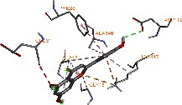 | 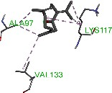
Figure 02 | 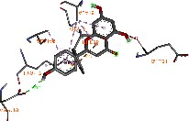 | 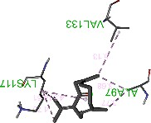
Figure 03 | 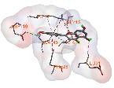 | 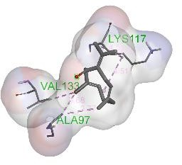
Figure 04 | 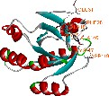 | 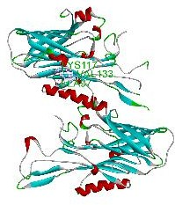
Figure 05 | 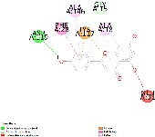 | 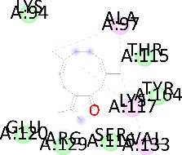

Task 05: Identify the highest-ranking Protein – ligand complex and input
the Interaction details into the table below.
Name | Distance | Category | Types
N:UNK1:C - A:ALA97 | 3.77101 | Hydrophobic | Alkyl
N:UNK1:C - A:ALA97 | 3.68404 | Hydrophobic | Alkyl
N:UNK1:C - A:VAL133 | 5.12826 | Hydrophobic | Alkyl
N:UNK1:C - A:LYS117 | 4.70026 | Hydrophobic | Alkyl
N:UNK1:C - A:LYS117 | 4.5107 | Hydrophobic | Alkyl
A:LYS117 - N:UNK1 | 4.51099 | Hydrophobic | Alkyl
N:UNK1:C - A:ALA97 | 3.77101 | Hydrophobic | Alkyl
N:UNK1:C - A:ALA97 | 3.68404 | Hydrophobic | Alkyl
N:UNK1:C - A:VAL133 | 5.12826 | Hydrophobic | Alkyl
N:UNK1:C - A:LYS117 | 4.70026 | Hydrophobic | Alkyl
N:UNK1:C - A:LYS117 | 4.5107 | Hydrophobic | Alkyl
A:LYS117 - N:UNK1 | 4.51099 | Hydrophobic | Alkyl
N:UNK1:C - A:ALA97 | 3.77101 | Hydrophobic | Alkyl
N:UNK1:C - A:ALA97 | 3.68404 | Hydrophobic | Alkyl

